**INTI International College Penang School of Engineering and Technology**

**3+0 Bachelor of Science (Hons) in Computer Science, in collaboration with Coventry University, UK**

**3+0 Bachelor of Science (Hons) in Computing, in collaboration with Coventry University, UK**

**Coursework cover sheet**

**Section A - To be completed by the student**

| Full Name:Ota Kazuki | |
| --- | --- |
| CU Student ID Number:P20012061 | |
| Semester:  **3** | |
| Session:  **April 2022** | |
| Lecturer:  **Nadhrah Abdul Hadi (nadhrah.abdulhadi@newinti.edu.my)** | |
| Module Code and Title:  **4067CEM Software Design** | |
| Assignment No. / Title:  **Continuous Assessment** | % of Module Mark:  **50** |
| Hand out Date:  **22nd April 2022** | Due Date:  **Task 1: 13 May 2022, by 11.59pm**  **Task 2: 1 July 2022, by 11.59pm**  **Task 3: 17 June 2022, by 11.59pm.**  **Task 4: 17 June 2022, by 11.59pm.**  **Task 5: 17 June 2022, by 11.59pm.** |
| Penalties: No late work will be accepted. If you are unable to submit coursework on time due to extenuating circumstances, you may be eligible for an extension. Please consult the lecturer. | |
| Declaration: I/we the undersigned confirm that I/we have read and agree to abide by the University regulations on plagiarism and cheating and Faculty coursework policies and procedures. I/we confirm that this piece of work is my/our own. I/we consent to appropriate storage of our work for plagiarism checking.  Signature(s): ________________________ | |

**Section B - To be completed by the module leader**

| Intended learning outcomes assessed by this work:  1. Understand and apply appropriate concepts, tools and techniques to each stage of the software development  2. Understand and apply design patterns to software components in developing new software  3. Demonstrate an understanding of project planning and working to agreed deadlines, along with professional, interpersonal skills and effective communication required for software production  5. Demonstrate an awareness of, and ability to apply, social, professional, legal and ethical standards as documented in relevant laws and professional codes of conduct such as that of the Malaysian National Computer Confederation. | | |
| --- | --- | --- |
| Marking scheme | Max | Mark |
| 1. User Story Mapping 2. Setting up a GitHub Repository 3. Creating a Class diagram and design pattern selection 4. Creating a Prototype User Interface and Usability Testing 5. Discuss the ethical issue related to the software | 20  10  30  20  20 |  |
| Total | 100 |  |

**The 4067CEM assessment should be completed as a full individual work over the course of the module. The assessment output are only judged at the end of the module and not by the expectations during that week. The assessment should be undertaken individually. All submissions will be checked against each other and the internet for possible plagiarism.**

Activities – These activities consists of **50%** of your coursework marks. It will be run throughout the semester and there will be a final submission at the end of the semester. These activities consists of activities that will be done in a software design phase.

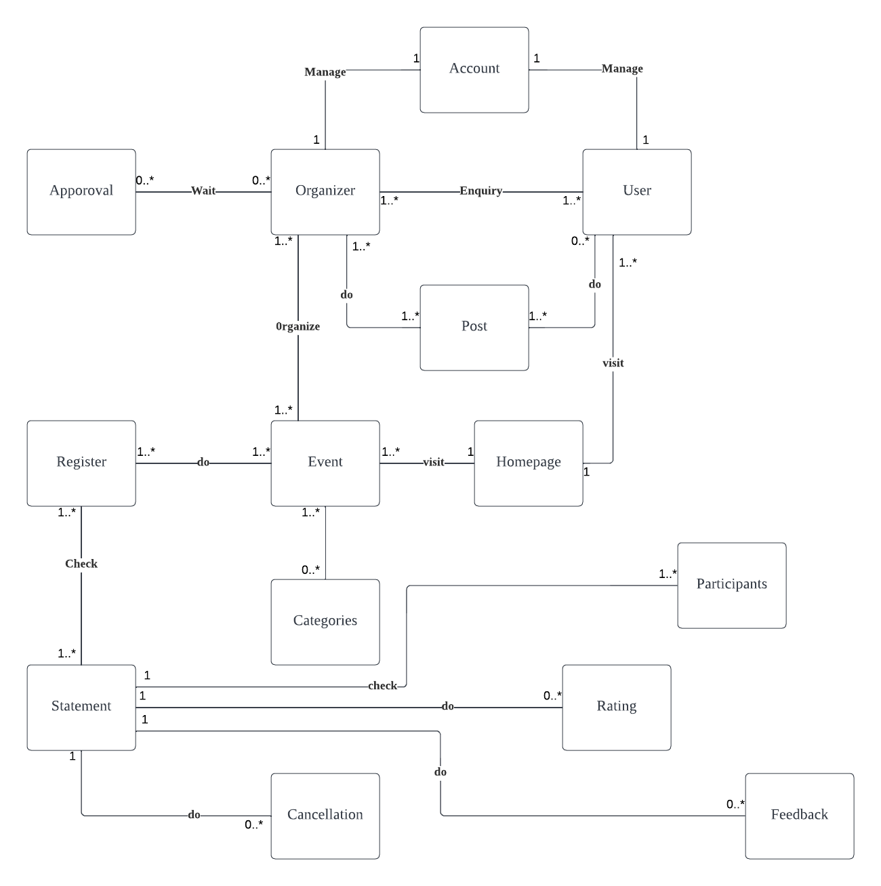

Class Explanation

Users: This Class manage personal information of the users

Organizer: This class manage personal information of the organizers

Account : This class manage personal information of users and organizer to login, edit,

delete their information

Post :This class manage all post that posted by organizers and users

Homepage: This class manage all operation for the website, work as relay point for each

Function

Event: This class manage all the event information in the system

Approval: This class manage all the approval form filled by organizers to get approval

From the college or university

Category : This class manage category of events for the sort function

Register : This class manage all registration made by users and organizer that

Conduct an event

Statement : This class manage event information, organizer information to make

Statement

Cancellation : This class manage cancellation form that filled by users that going to

Cancel to join an event

Participant : This class manage user information that register to join an event

Rating : This class manage all rating that made by participant of an event

Feedback: This class manage all feedback that made by participants of an event

First in this website they have two users which is “Organizer” and “User”

Both will manage accounts to login, edit,or delete their personal information.

Users' perspective .

What users can do in this website is

-visit homepage

-visit event page

-make enquiry to organizer

-Create or share their experience in the post page.

From the event page users can categories the event if they want.

By visiting the event page users can register any events they want.

After the registration they will get a statement that can check details

And can edit status such as cancellation of events.

Also they can do feedback, rating, and check the participants of the events.

Organizer perspective.

Organizers have different steps to reach their page.After their login as organizer.

They will directly landing to the organizer event page.in different tab

From there they can

-organize new event

-edit organized event

-see past event

-send approval form to university/collage.

| Notation | Relation |
| --- | --- |
| 0…* | Zero to many |
| 0…1 | Zero to one |
| 1 | One and only one |
| 1…* | One to many |

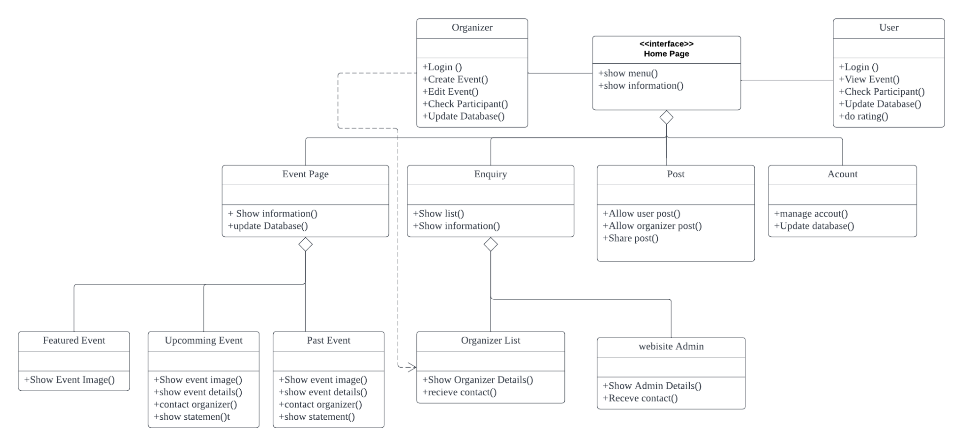

The Problem of the system :

How to add and manage a lot of Events?

In the College/University they have a lot of clubs, committees, students, lecturers, staff, and outsiders that can be organizers of events.

To update the information from time to time, they need a place that can update information without any interference.

Such as the closure of website due to the update of information.

So from the problem….

I Choose Factory Method to represent this system

The image on top is the class diagram that I drew based on the design pattern I chose.

Why I chose Factory method is

By applying the pattern, it will be possible to switch between the necessary objects at runtime while maintaining a sparse level of coupling between classes. This will provide easy switching for classes that could not be prepared at development time but will be brought in later, or for classes that may be developed in the future.

While this has the advantage of simplifying the class structure, the client-side classes are usually used for processing other than generation, and each time the number of classes to be generated increases, it will be necessary to subclass the user-side classes. Which one to use must be determined by checking the number of client classes and balancing their responsibilities.

Advantage of factory method is

Lower-level module implementations can be exchanged

No need to worry about details of lower modules when implementing a higher-level module

Upper-level modules can be tested even if the lower-level modules are not completed.

Upper modules are not affected by changes in lower modules.

DIsadvantage of factory method is

When going to the coding part we have to code dozens of extra lines.

From the information above I choose Factory method to draw a diagram.